**Create Your Company’s Trello Board**

1. Assign one person to follow the instructions below to create your company’s Trello board.
2. Copy the GenTech Trello template by following these steps:
   1. Be sure you’re logged into Trello and at this URL: <http://tinyurl.com/GenTech2014TrelloTemplate>
   2. Using the menu bar on the right click “Copy Board”.

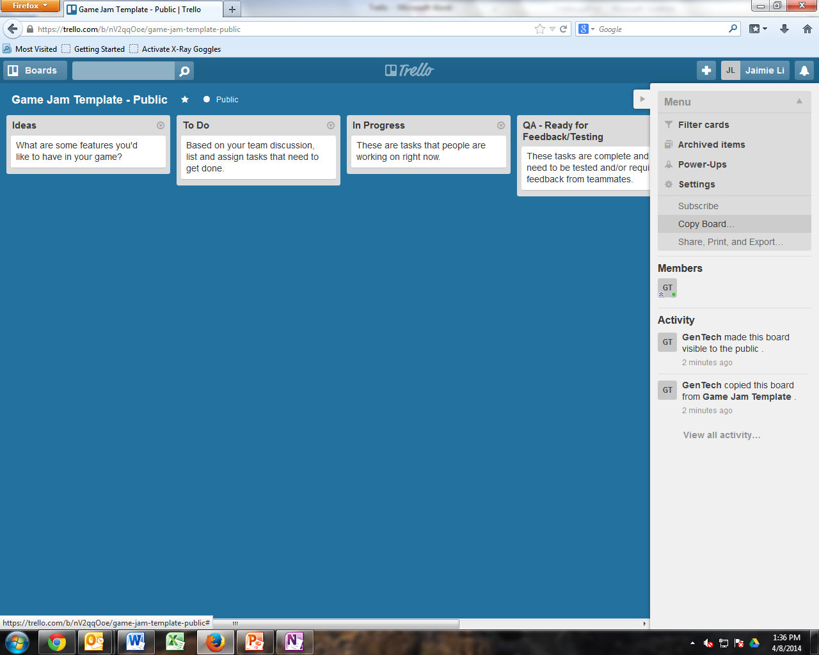

* 1. Title your Trello board with your team name and create your board.

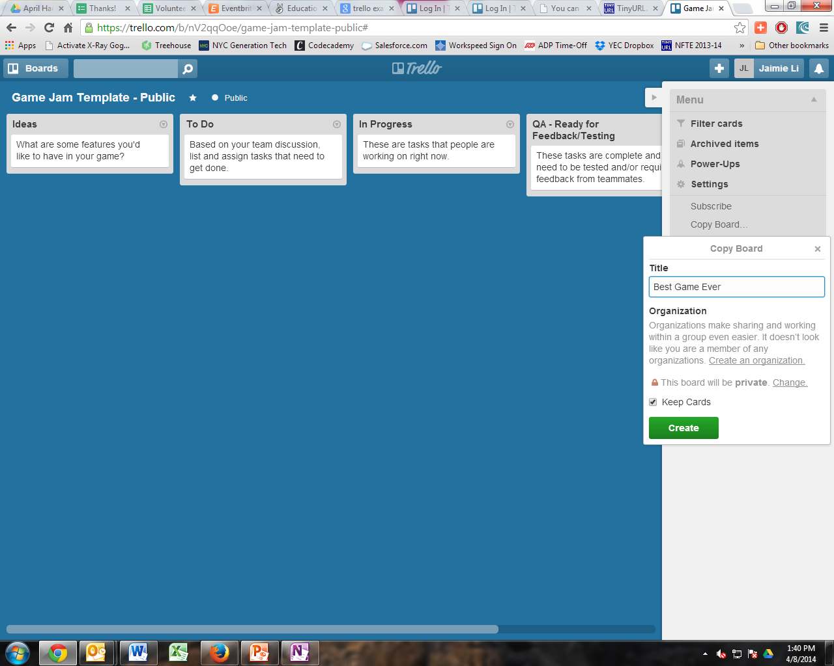

1. Add all your team members to the Trello board. Search for their Trello user name and/or invite new members by typing in their email address.

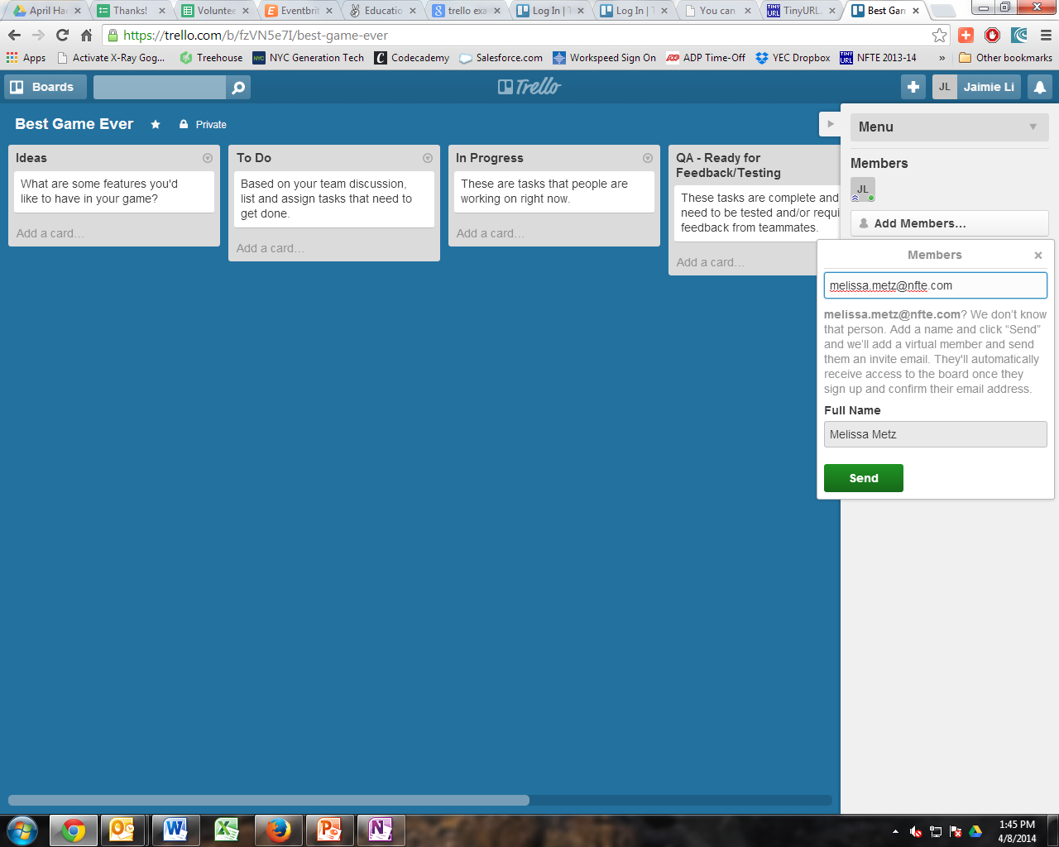

1. Add GenTech to your Trello board.

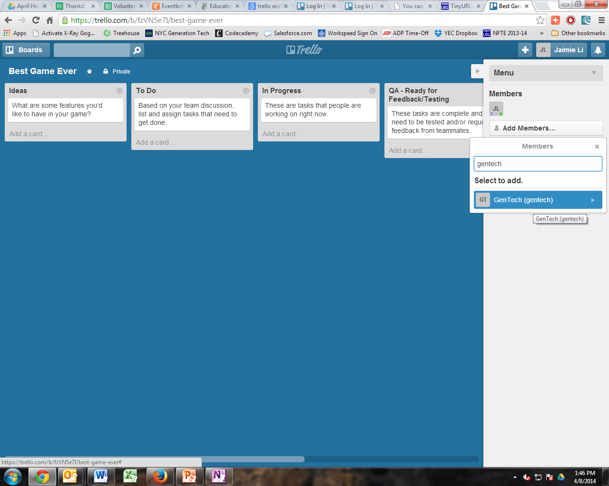

1. With your team, come up with a list of *at least 10* smart objects / action steps. Add these to your Trello board by adding cards to the appropriate list (e.g., Marketing Collateral).